IT23234598

Perera O.N.K

Probability and Statistics

Lab 06

1 i)

ii) 

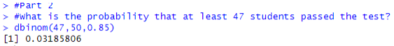

2 i)

ii)



iii) 

